SepsisGuard: An AI and IoT-Driven Early Sepsis Warning Wearable System for Rural Hospitals
Anaas Rawoof.S ¹, Arvin.M¹, Vishal.D^{1*}, Dr. A.Manikandan²
¹UG Students, Department of Artificial Intelligence and Machine Learning,
Vels Institute of Science, Technology & Advanced Studies (VISTAS), Chennai, Tamil Nadu, India.
²Associate Professor, Department of Artificial Intelligence and Machine Learning,
Vels Institute of Science, Technology & Advanced Studies (VISTAS), Chennai, Tamil Nadu, India.
Contributing authors: Anaas Rawoof S -anaasrawoof3@gmail.com; Arvin M– johnalexarvin4@gmail.com; Vishal D-duraivishal7@gmail.com
Dr. A.Manikandan– mani.se@vistas.ac.in

Abstract—SepsisGuard is an inexpensive, internet-free edge-AI early-warning system designed for use in resource-limited rural wards. The system combines MAX30100 and TMP117 sensors with an ESP32-C3 wearable device and a Raspberry Pi 4B gateway. The gateway is responsible for carrying out feature engineering, performing Random Forest inference, maintaining local SQLite logs, hosting the dashboard, and enabling escalation via GSM. It includes twelve engineered physiological features, which are made up of four features relating to current vital signs, four short-term trend features, and four variability features. The development manuscript shows an AUROC of 0.87 on held-out MIMIC-III data and inference times of less than 50 ms when using Raspberry Pi hardware. These results from the development phase need to be verified in a prospective clinical study.
Index Terms—the prediction of sepsis, wearable sensors, edge AI, IoT in healthcare, Random Forest, MIMIC-III, rural healthcare, offline inference.
I. INTRODUCTION
Sepsis has the potential to lead to a quick deterioration of physiological function and can advance to septic shock and failure of multiple organs. In wards where resources are limited, manual checks of the vital signs at regular intervals may fail to detect any deterioration between those checks. SepsisGuard is concerned with carrying out frequent physiological sensing and performing early-warning calculations at the local level.
The system makes use of wearable sensing, a pre-check based on qSOFA, trend-aware machine learning, local inference, data logging, dashboard visualization, and GSM-based escalation. In this architecture the main processes involving sensing, inference, storage and visualization are kept local, while cellular connectivity is only needed for SMS escalation.
II. PROBLEM STATEMENT AND OBJECTIVES
The project deals with the engineering problem of offering affordable, continuous, early-warning support that can be used locally where there is a lack of cloud connectivity and where expensive bedside monitors are not available.
TABLE I
SEPSISGUARD OBJECTIVES
Objective | Implementation
Repeated monitoring | HR, SpO₂, RR, temperature
Trend analysis | 30-minute trend features
Variability analysis | Previous six readings
Edge inference | Random Forest on Raspberry Pi 4B
Local operation | SQLite + local dashboard
Escalation | Local alarm + GSM SMS

III. SYSTEM ARCHITECTURE
Figure 1 presents the main block-level representation of the proposed system.

Figure 1. The system architecture of SepsisGuard.
The wearable device includes the MAX30100 for measuring SpO₂, heart rate and respiratory rate using PPG technology, as well as the TMP117 for body temperature, and the ESP32-C3 is in charge of carrying out the sensor data acquisition and sending the data to the local ward gateway.
The Raspberry Pi 4B takes in the packet and carries out feature engineering, performs inference using a Random Forest method, logs the data in SQLite and hosts the dashboard. When the configured risk thresholds are reached, the alert system generates local warnings and, if the high-risk threshold is reached, triggers a GSM SMS alert.
IV. BLOCK DIAGRAM AND DATA FLOW
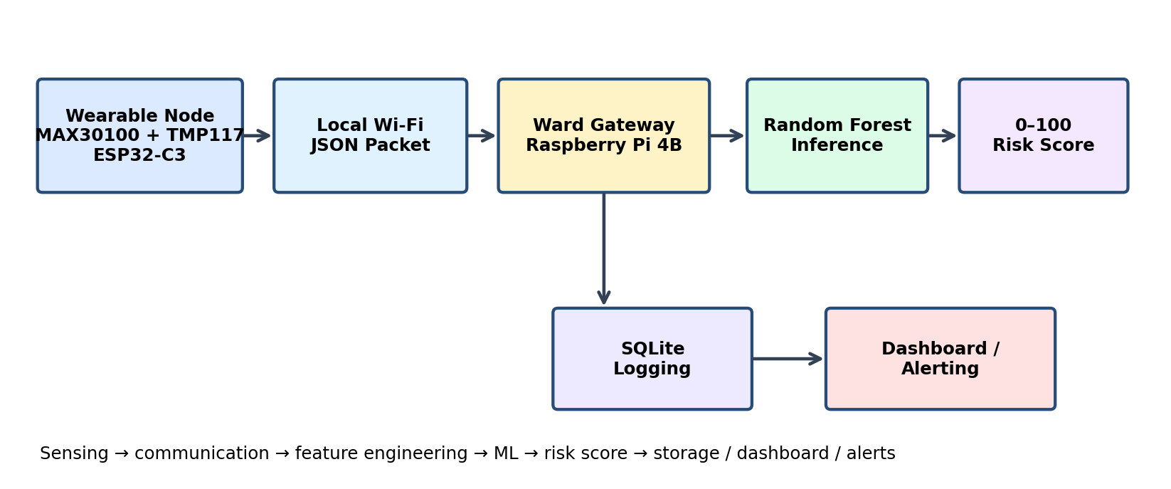
Figure 2. Block diagram of the SepsisGuard architecture and data flow.
TABLE II
DATA-FLOW INTERFACES
Stage | Input | Output
Sensing | Physiological signals | Raw vital signs
Communication | ESP32-C3 packet | JSON data
Gateway | Sensor packet | Engineered features
ML | 12 features | Risk score
Storage | Reading + score | SQLite record
Presentation | Current/history | Dashboard
Escalation | High-risk event | Alarm/SMS

V. FEATURE ENGINEERING
The input for the Random Forest includes twelve engineered physiological features, four of which relate to the current vital signs, four relate to 30-minute trends, and four relate to variability in the previous six readings; the qSOFA-informed pre-check is regarded as a separate safety signal.
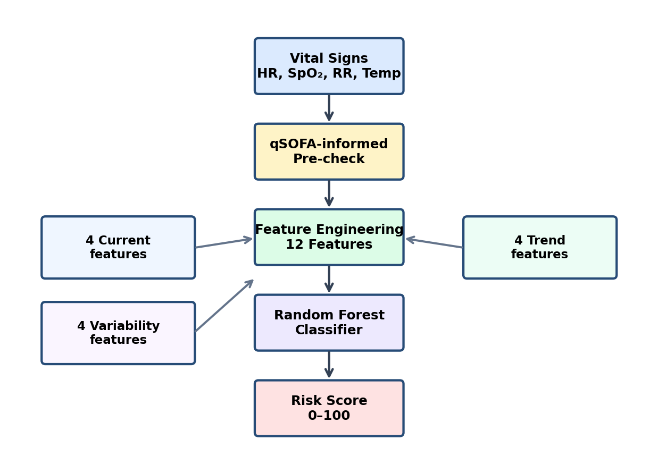
Fig. 3. Feature-engineering flowchart.
A. Current-value features
The current-value features are a way of describing the present physiological state on the basis of measurements of the heart rate, SpO₂, respiratory rate and temperature.
B. Trend features
The short-term trends shown over a 30-minute period indicate the direction of change and give information which cannot be obtained from a single static measurement.
C. Variability features
The features relating to variability use the earlier six readings in order to show short-term fluctuations and instability.
VI. RISK THRESHOLD FLOWCHART
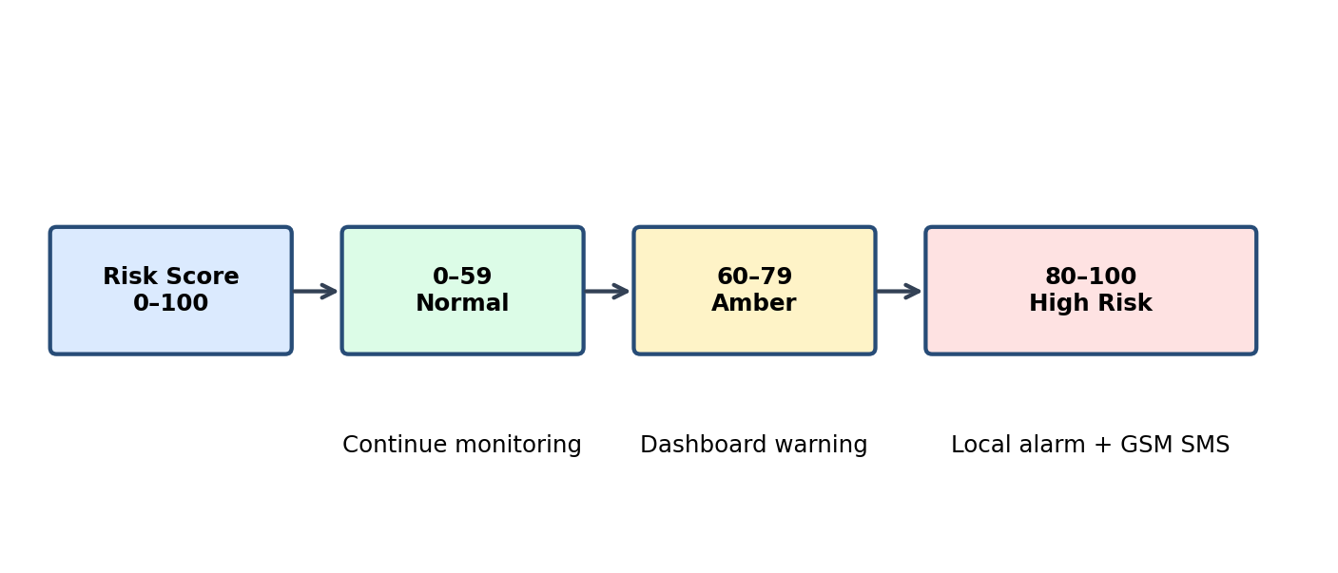
Figure 4. Flowchart of the risk-threshold decision process.
The recorded thresholds are 0 to 59 for normal monitoring, 60 to 79 for an amber warning, and 80 to 100 for high-risk escalation; the dashboard is intended to display an amber warning when the value is above 60, and a local alarm together with a GSM SMS are meant to be activated when the value exceeds 80.
VII. FEATURE-TO-DECISION SUMMARY
TABLE III
TWELVE-FEATURE MODEL STRUCTURE
Feature group | Count | Purpose
Current vital signs | 4 | Present physiological state
30-minute trends | 4 | Short-term change
Variability | 4 | Recent instability
Total Random Forest features | 12 | Model input

VIII. MACHINE LEARNING MODEL
The Random Forest classifier is used at the Raspberry Pi 4B gateway, where its output is converted into a 0–100 risk score and then saved in SQLite; local inference enables the system to function even when there is no continuous connection to the cloud.
A. Reported Development Results
The source manuscript states that the AUROC is 0.87 when evaluated on the MIMIC-III data that was not used in training and that the model inference time is below 50 ms on Raspberry Pi 4B hardware. However, these results are merely indicative of development performance and do not prove clinical effectiveness.
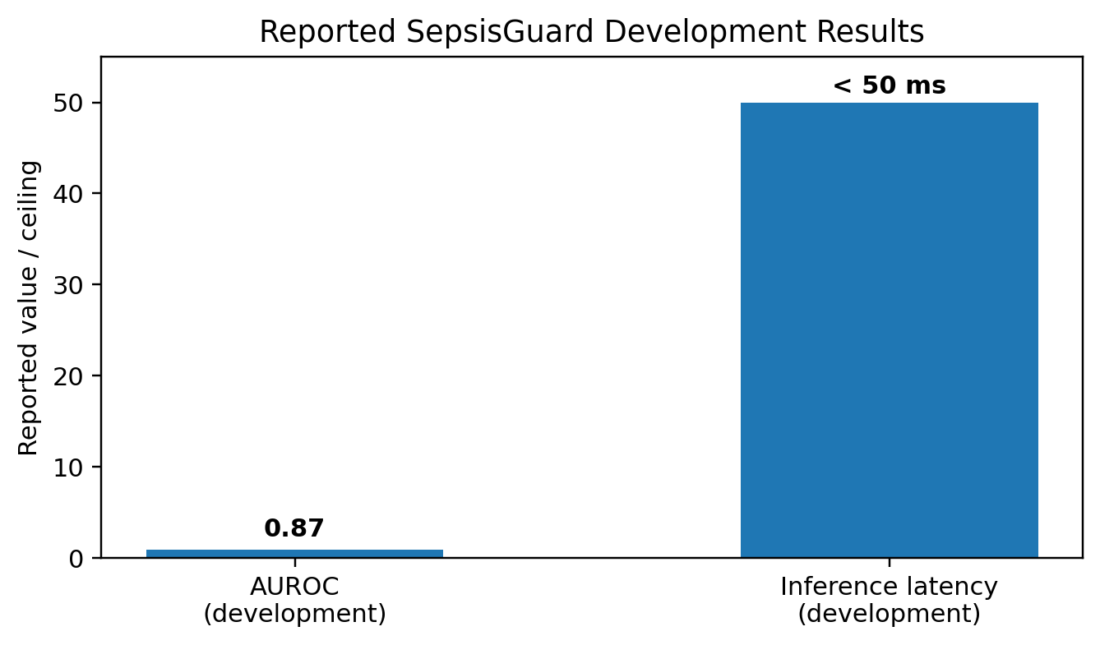
Figure 5. A visual summary of the results of the development evaluations reported.
TABLE IV
EVALUATION METRICS AND EVIDENCE STATUS
Metric | Reported / current status
AUROC | 0.87 on held-out MIMIC-III
Inference latency | < 50 ms on Raspberry Pi 4B
Sensitivity | Not reported; proposed
Specificity | Not reported; proposed
Calibration | Not reported; proposed
False-alert burden | Not reported; proposed
Alert latency | Not reported; system testing needed

The results shown are limited to those values which are supported by the source manuscript, and the sensitivity, specificity, calibration and alert-latency values have been deliberately left unfabricated.
IX. PROPOSED EVALUATION
TABLE V
PROPOSED VALIDATION PLAN
Test area | Method / measure
Model | AUROC, sensitivity, specificity, precision, recall
Calibration | Calibration and confidence analysis
Sensors | Reference-device comparison
Alerting | Alert latency and false-alert burden
Connectivity | Packet loss and GSM delivery
Power | Battery endurance
Usability | Dashboard interpretability and response

X. HARDWARE AND SOFTWARE REQUIREMENTS
TABLE VI
SYSTEM REQUIREMENTS
Component | Role
ESP32-C3 | Wearable controller and communication
MAX30100 | SpO₂, HR, PPG waveform
TMP117 | Body temperature
Raspberry Pi 4B | Gateway and local inference
SQLite | Local data logging
SIM800L | GSM SMS escalation
Flask / Web UI | Dashboard hosting

XI. IMPLEMENTATION STATUS
TABLE VII
IMPLEMENTATION STATUS
Module | Status | Validation need
Sensor acquisition | Prototype implemented | Clinical-grade accuracy
qSOFA pre-check | Implemented | Prospective assessment
Random Forest | Development evaluated | Prospective validation
SQLite + inference | Implemented | Reliability benchmarking
Dashboard | Implemented | Latency/usability
SMS escalation | Prototype | Cellular delivery testing

XII. LIMITATIONS
The greatest limitation lies in the fact that there is a domain shift between MIMIC-III, which involves a US intensive care unit population monitored with clinical-grade equipment, and the intended use in rural India where lower-cost sensors will be employed. Differences may exist in terms of population characteristics, clinical procedures and the accuracy of the measurements. Also, the respiratory rate derived from PPG can be influenced by motion and by the position of the sensor.
The risk score serves as a tool to aid in decision-making and is not a medical diagnosis. The qSOFA-informed pre-check should not be regarded as a replacement for clinical assessment. The development AUROC and inference latency should not be taken as proof of real-world clinical accuracy.
XIII. FUTURE WORK
Future work includes prospective clinical validation, patient-level and time-aware evaluation, sensor accuracy testing, false-alert analysis, battery and connectivity testing, improved respiratory sensing, and refinement of the feature set.
XIV. CONCLUSION
SepsisGuard presents an integrated wearable and edge-AI framework that links physiological sensing, local feature engineering, Random Forest inference, SQLite logging, dashboard visualization and GSM-based escalation. The architecture is designed for resource-constrained wards and offline-first operation. The reported development results demonstrate implementation-level feasibility, while prospective validation remains necessary for clinical effectiveness and generalization.
REFERENCES
[1] M. Singer et al., "The Third International Consensus Definitions for Sepsis and Septic Shock (Sepsis-3)," JAMA, 2016.
[2] T. Desautels et al., "Prediction of sepsis in the intensive care unit with minimal electronic health record data: A machine learning approach," JMIR Medical Informatics, 2016.
[3] A. E. W. Johnson et al., "MIMIC-III, a freely accessible critical care database," Scientific Data, 2016.
[4] A. Kumar et al., "A wearable microcontroller-based vital-sign monitoring system for rural healthcare wards," 2020. Bibliographic details should be verified before publication.
[5] L. Zhang and Y. Liu, "Edge deployment of Random Forest and XGBoost classifiers on Raspberry Pi for low-latency health inference," 2022. Bibliographic details should be verified before publication.
[6] Ministry of Health and Family Welfare, Government of India, Rural Health Statistics, 2021.

